**Assignment 12**

*Problem Statement:*

Installing and configure DHCP server and write a program to install the software on remote

machine.

*Prerequisite:*

1

2

. Knowledge about IP and Subnets.

. Linux basiccommands.

*Learning Objectives:*

1

2

. Understand the concept of DHCP.

. Configuring DHCP and installation of software.

*New Concepts:*

1

2

. Crimping

. Access Point Configuration

*Theory:*

DHCP (Dynamic Host Configuration Protocol) is a protocol that lets

network administrators manage centrally and automate the assignment

of IP (Internet Protocol)configurations on a computer network.

When using the Internet's set of protocols (TCP/IP), in order for a

computer system tocommunicate to another computer system it needs a

unique IP address.

●

●

●

Without DHCP, the IP address must be entered manually at each

computer system. DHCP lets a network administrator supervise and

distribute IP addresses from a centralpoint.

The purpose of DHCP is to provide the automatic (dynamic) allocation

of IP client configurations for a specific time period (called a lease

period) and to eliminate the work necessary to administer a large IP

network.

●

●

When connected to a network, everycomputer must be assigned a unique address.

However, when adding a machine to a network, the assignment and

configuration of network (IP) addresses has required human action.

The computer user had to request an address, and then the administrator

would manually configure the machine. Mistakes in the configuration

process are easy for novices to make, and can cause difficulties for both

the administrator making the error

●

as well as neighbors on the network. Also, when mobile computer users

travel between sites, they have had to relive this process for each

different site from which they connected to a network.

In order to simplify the process of adding machines to a network and

assigning unique IP addresses manually, there is a need to automate the

task.

●

The introduction of DHCP alleviated the problems associated with

manually assigning TCP/IP client addresses. Network administrators

have quickly appreciated the importance, flexibility and ease-of-use

offered in DHCP.

*Advantages of DHCP:-*

DHCP has several major advantages over manual configurations.

Each computer gets its configuration from a "pool" of available numbers

automatically for a specific time period (called a leasing period),

meaning no wasted numbers.

●

●

When a computer has finished with the address, it is released for another

computer to use. Configuration information can be administered from a

single point.

Major network resource changes (e.g. a router changing address),

requires only the DHCP server be updated with the new information,

rather than everysystem.

*DHCP message types:*

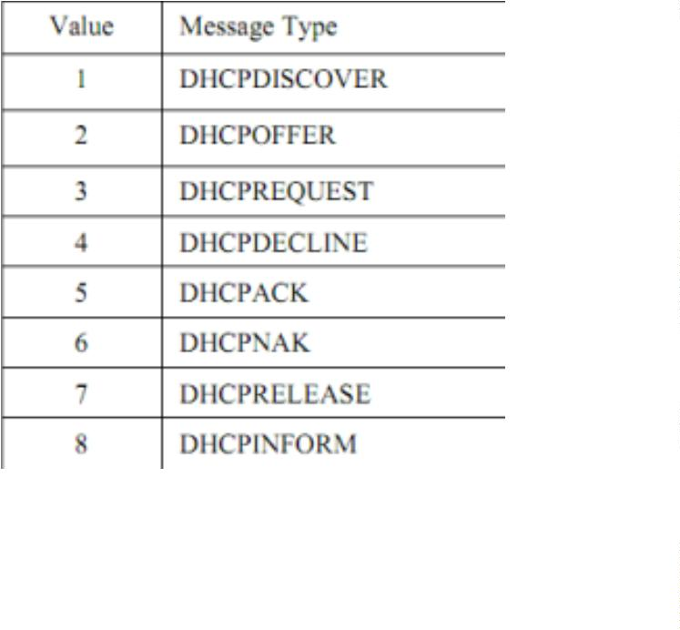

**DHCP Operations:-**

1. DHCP Discover

DHCP Offer

1

2

. DHCP Discover: At this time, the DHCP client can start to use the IPaddress

. DHCP Release: At this time, the DHCP client has released the IP address

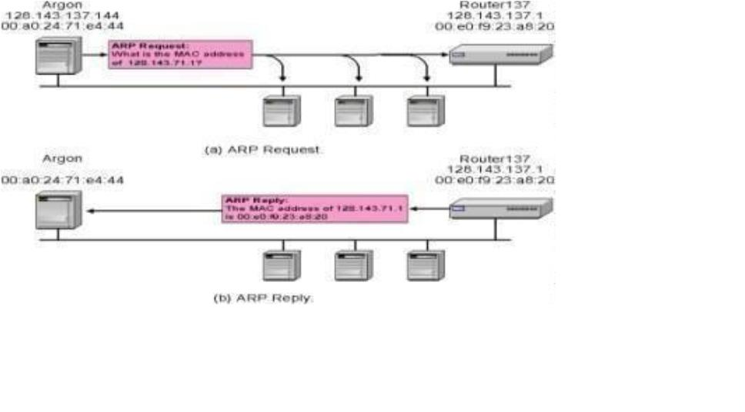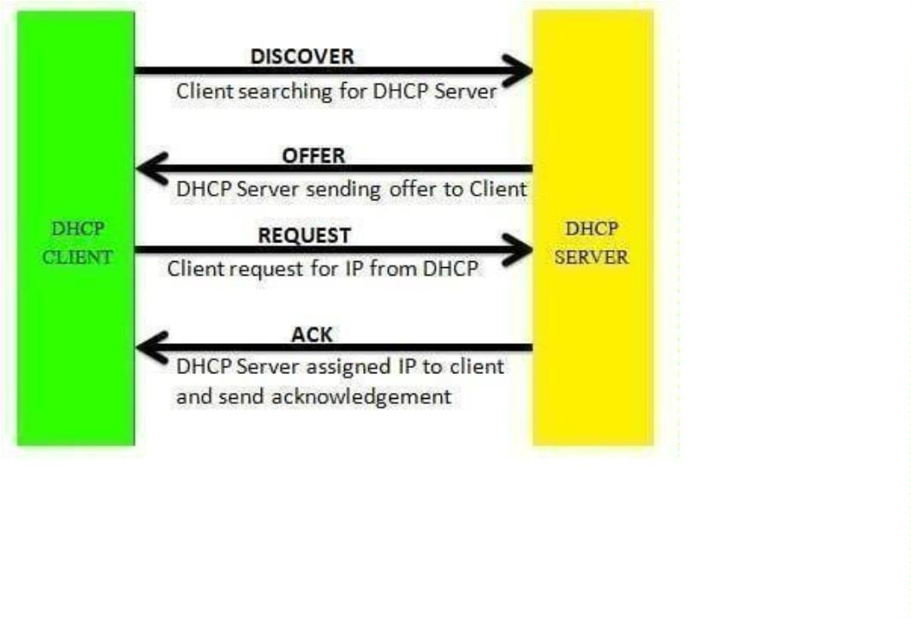

*5*

*.4.4 Installing DHCP in Ubuntu:*

**Open terminal and type following commands:-**

. sudo apt-get install isc-dhcp-server

. sudo gedit /etc/dhcp/dhcpd.conf then make changes in file....

1

2

default-lease-time 600; max-lease-time 7200;

option subnet-mask 255.255.255.0;

option broadcast-address 10.1.32.255;

subnet 192.168.1.0 netmask 255.255.255.0

Range 10.1.32.10 10.1.32.20;}

3.

default-lease-time 600; max-lease-time 7200;

option subnet-mask 255.255.255.0;

option broadcast-address 10.1.32.255;

subnet 192.168.1.0 netmask 255.255.255.0

range 10.1.32.10 10.1.32.20; }

3. save file and close

4. again on terminal give following commands....

sudo service isc-

dhcp-server restart

sudo service isc-

dhcp-server start

5. On another PC in Internet properties change to Obtain IP address

automatically andthen check the IP address.

*Conclusion:*

Hence we Installed and Configured DHCP and studied Installation of

Software on remoteMachine.

*Assignment 14: Group B*

**Problem Definition:** Study and Analyze the performance of HTTP, HTTPS and

FTP protocolusing Packet tracer tool.

*Prerequisite:*

**Learning Objectives**:

1

. To understand the concept of HTTP, HTTPS and FTP Protocol.

*Theory*

The File Transfer Protocol (FTP) is a standard network protocol used for the

transfer of computerfiles between a client and server on a computer network.

FTP employs a client-server architecture whereby the client machine has an FTP

client installed and establishes a connection to an FTP server running on a remote

machine. After the connection has been established and the user is successfully

authenticated, the data transfer phase can begin.

Worth noting: Although FTP does support user authentication, all data is sent in

clear text, including usernames and passwords. For secure transmission that protects

the username and password, and encrypts the content, FTP is often secured with

SSL/TLS (FTPS) or replaced with SSH File Transfer Protocol (SFTP).

Let’s now do FTP configuration in Packet Tracer:

1

. Build the network topology.

FTP topology.PNG

2

. Configure static IP addresses on the Laptop and theserver.

Laptop: IP address: 192.168.1.1 Subnet Mask: 255.255.255.0

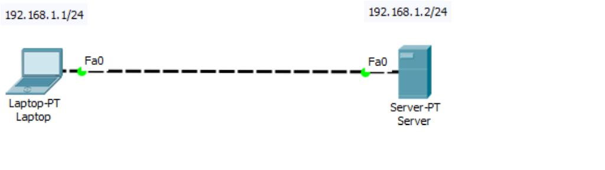

Server: IP address: 192.168.1.2 Subnet Mask: 255.255.255.0

. Now try using an FTP client built in the Laptop to send files to an FTP server

3

configured in theServer.

From the Laptop’s command prompt, FTP the server using the server IP address

by typing: ftp192.168.1.2

Provide the username(cisco) and password(cisco) [which are the defaults] for ftp login.

ftp from laptop.PNG

You are now in the FTP prompt .

PC0 has an FTP client which can be used to read, write, delete and rename files

present in theFTP server.

The FTP server can be used to read and write configuration files as well as IOS

images. Additionally, the FTP server also supports file operations such rename,

delete and listing directory.

With that in mind, we can do something extra. So let’s do this:

4

. Create a file in the Laptop then upload it to the server usingFTP.

To do this, open the Text Editor in the Laptop, create a file and give it your

name of choice.Type any text in the editor then save your file. e.g.

myFile.txt.

5

. Now upload the file from the Laptop to the server using FTP. (An FTP

connection has to bestarted first. But this is what we’ve done in step 3)

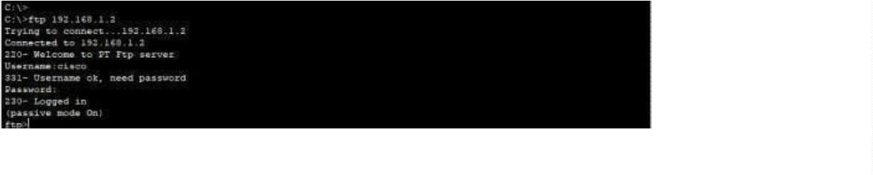

So to do an FTP upload, we’ll type:

put MyFile.txt

put My File to FTP directory.PNG

6

. Once file upload is successful, go to the Server FTP directory to verify if the file

sent has been received . To do this, go to Server-> Services->FTP. Here look for

MyFile.txt sent from the laptop.

MyFile.txt really send to sever.PNG

Something extra: To check other FTP commands supported by the FTP client

running on the Laptop (or PC), you can use a question mark (?) on the Laptop’s

command prompt as shown below:

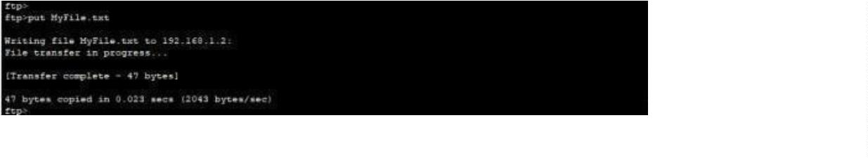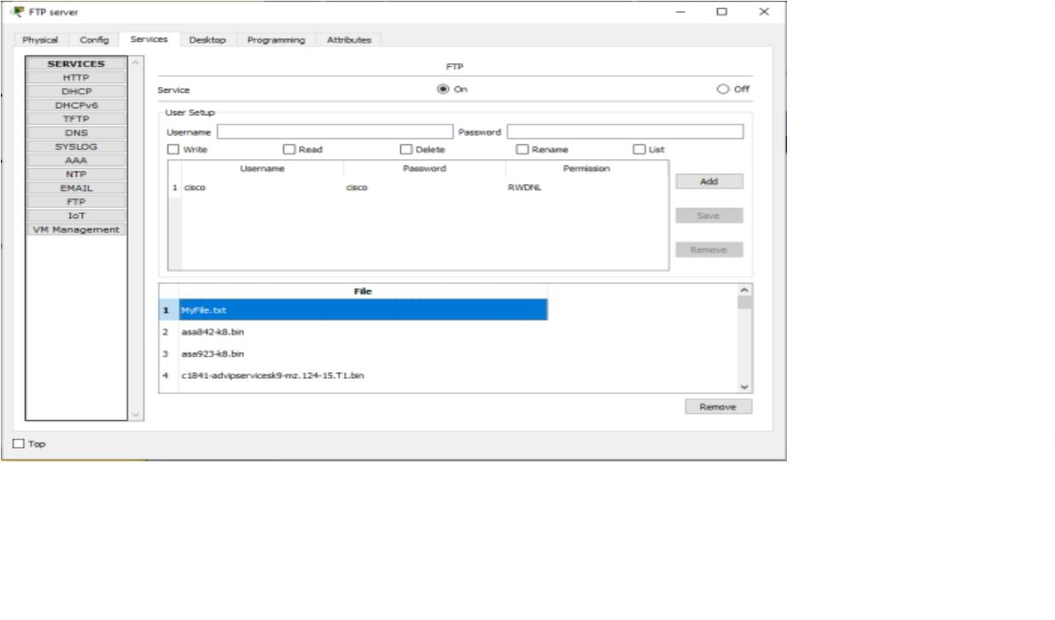

All FTP commands supported

You can see the put command that we used to upload our file to the FTP server.

Other commandslisted include:

get-used to get(download) a file from the server.

For example: get MyFile.txt

delete– to delete a file in the FTP directory with the server

For example, we can open an HTTP directory in the server by typing: cd /http.

This will changethe current directory from FTP directory to HTTP directory

Once the http directory is open, you can upload a file to the HTTP server. You’re

now uploadinga file to an HTTP folder(directory) using FTP.

For example: put MyFile.txt

To see this working, let’s open an HTTP directory and upload(put) a file

to it using FTP:changing directory then put files to HTTP directory using

FTP

You can now check up in the HTTP directory in the server and verify that the file uploaded

from

the Laptop(MyFile.txt) is well received:

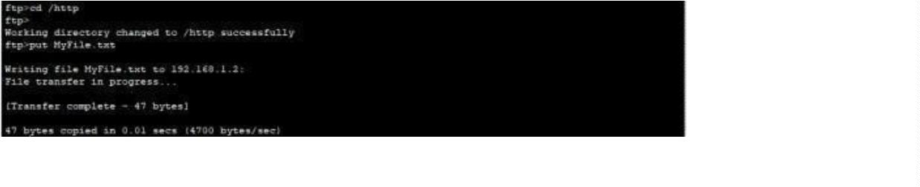

MyFile.txt really send to HTTP server

Notice that we are uploading files to an HTTP Server directory using File Transfer

Protocol.(FTP). This is what actually happens when you use an FTP client such as

FileZilla clientto upload files to a website. In our case here, we are using an FTP

client built-in the Laptop.

This may interest you: The first FTP client applications were command-line

programs developed before operating systems had graphical user interfaces, and

are still shipped with most Windows and Linux operating systems. (Actually this is

what we have been using this far). Many FTP clients(e.g. FileZilla) and automation

utilities have since been developed for desktops, servers, mobile devices, and

hardware. FTP has also been incorporated into productivity applications, such as

HTML editors.

We’ll create an html file in our Laptop, upload it to HTTP server directory using

FTP, then try to access the file from the Laptop’s browser.

On the Laptop, open the text editor, then type some markup(html) and save the file

with the extension .html. See all this below:

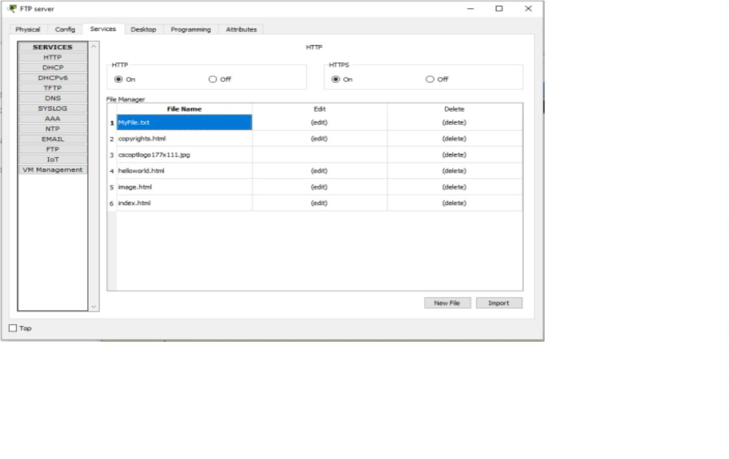

File2 HTML code

Save your file as an html file like this:

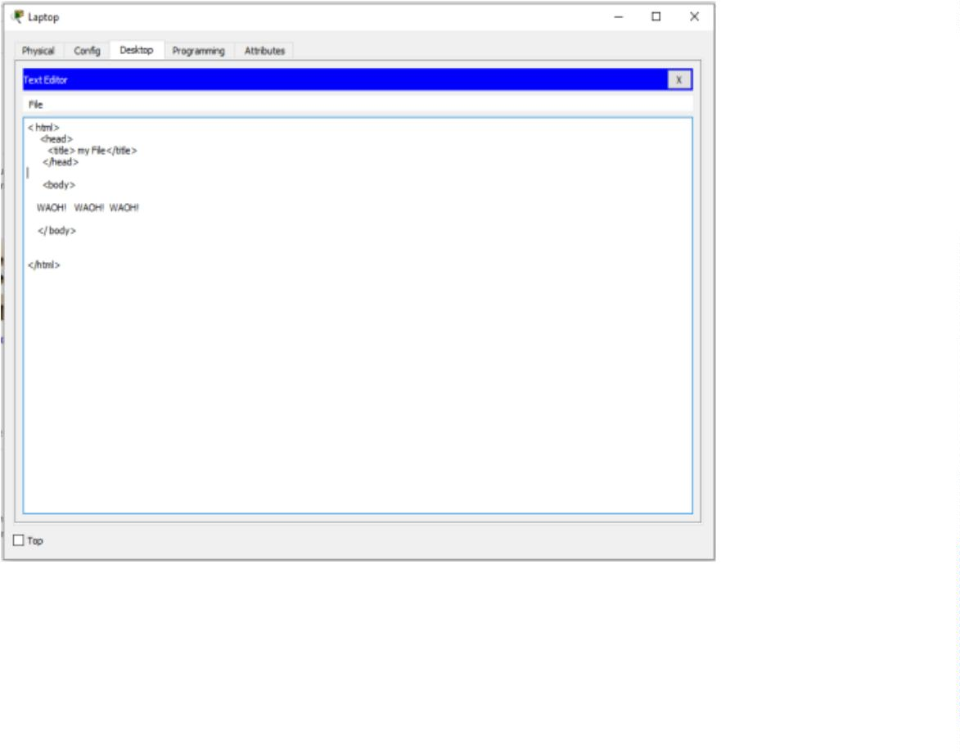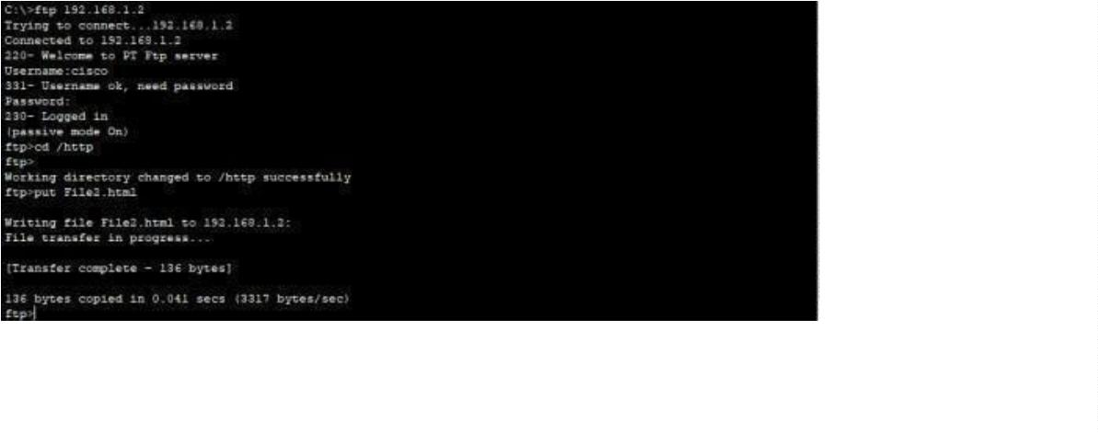

File2 html.PNG

Now upload the file( File2.html) to the HTTP server using FTP. This is easy.

We’ve already done it previously!

If you’re already in the HTTP directory, you just need to type: put File2.html. If

no, first ftp the server(ftp 192.168.1.2), provide the login username(cisco) and

password(cisco); change the current directory to HTTP(cd /http) , and finally

upload the html file onto the HTTP directory(putFile2.html)

Sending File2. html to HTTP directory.PNG

Check whether the html file uploaded has been received in the

HTTP directory:Go to Server->Services-> HTTP. Then look up

for the file in the File Manager.

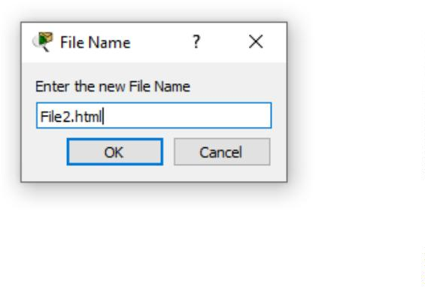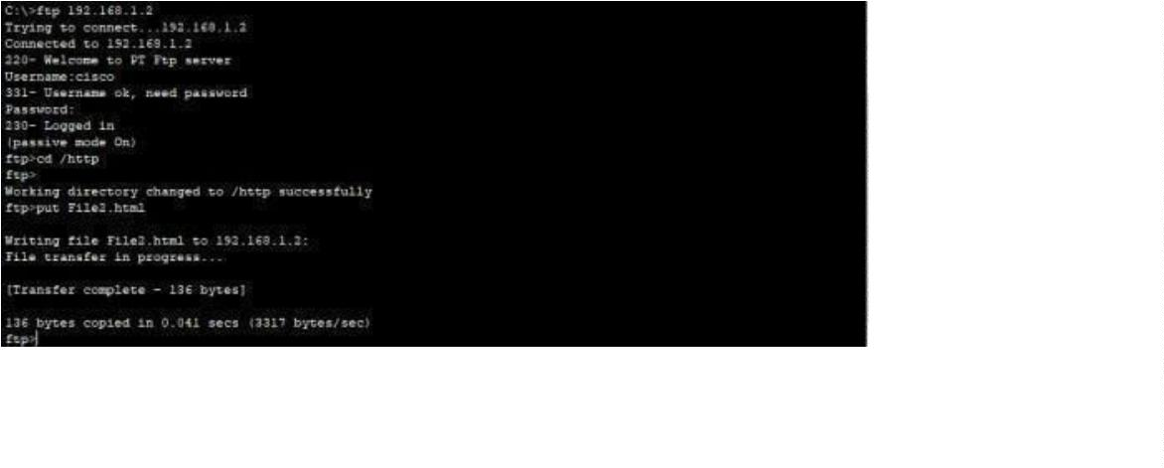

File2 HTML really uploaded into HTTP directory.PNG

Now edit index.html file in the HTTP directory so as to include a link to File2 that

we’ve just uploaded. This will make File2 accessible from the Laptop’s browser.

To do this, locate index.html then click edit. Proceed to edit it as shown below.

Then save and accept overwrite.Index.html editing to include File2 html.PNG

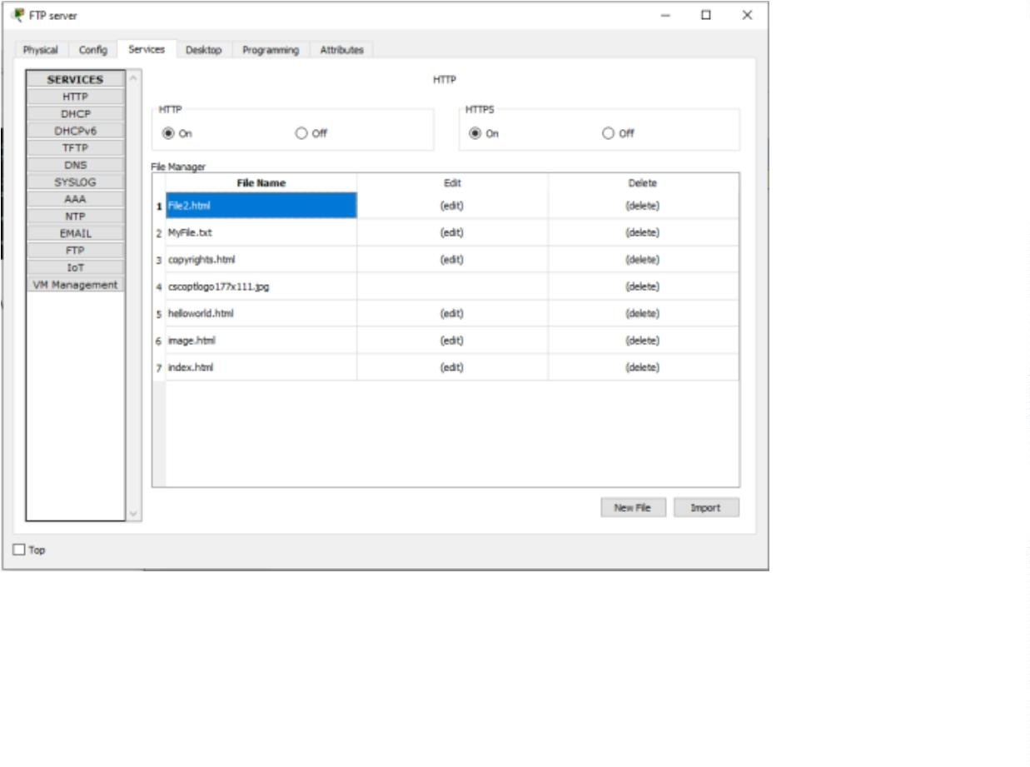

Finally, try to access the newly uploaded file from the Laptop’s browser.

So go to the Laptop’s browser and access the server using the server’s IP address.

By doing this, the browser is making an http request to the server. The server will

respond to the Laptop with the index.html file containing a link to File2 which

we’ve uploaded from the Laptop using FTP.

Http response with File2.PNG

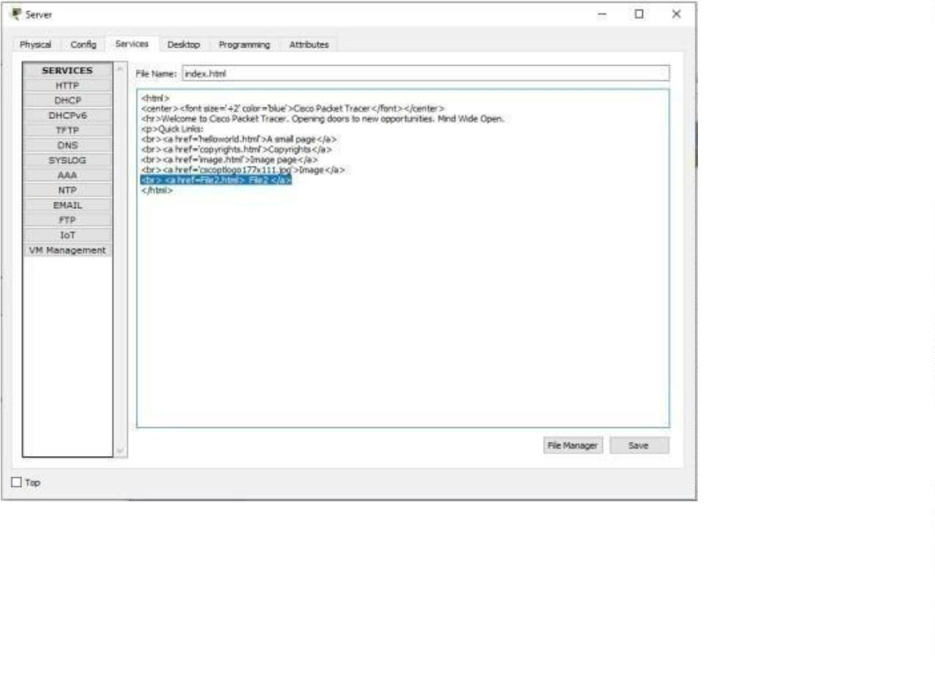

Click File2 link to view the contents of the file in the browser.

*Conclusion:*

We Studied and analyze the performance of HTTP, HTTPS and FTP protocol

using Packet tracertool.

